Tutorials for IT 210

# Welcome

Welcome to IT 210 Business Applications with C++, the first in a series of two C++ classes offered here at Old Dominion University! Let’s get started!

Table of Contents

Welcome 1

MoVE – Monarch Virtual Environment (move.odu.edu) 2

Saving your Work in MoVE 3

Launching Dev-C++ 4

Dev-C++ on your own computer 5

For older versions of Windows (XP, Vista, or 7) 5

For modern versions of Windows (8, 8.1) 5

For Mac users 6

Using MoVE (Easiest) 6

Installing Dev-C++ using Bootcamp 7

Using Virtual Box 9

For Linux users 10

Microsoft Visio (Homework Flowcharts) 11

# MoVE – Monarch Virtual Environment (move.odu.edu)

**Powered by VMware Horizon**

MoVE is how we can access any ODU computer. This brings up the exact same desktop as if you were on your classroom computer, or a computer at Perry Library. For starters, you will need to grab the Horizon Client software from VMware’s website: <https://my.vmware.com/web/vmware/info/slug/desktop_end_user_computing/vmware_horizon_clients/3_0>

VMware Horizon works on the following systems:

* Windows, including Windows RT (“Windows Store”, “Modern”, or “Metro”)
* Mac
* Linux
* iOS
* Android

Once installed on your system, here is what you’ll need to know:

* The server you’re connecting to is move.odu.edu (http://move.odu.edu is wrong, type carefully)
* Use your MIDAS username & password to log in
* Agree to sign your life away to ODU
* Select General Lab Software
  + If you get another login screen here, use your MIDAS username & password again

## Saving your Work in MoVE

There are two ways to save your work while on the MoVE desktop. The easiest way is to attach a USB stick to the virtual environment

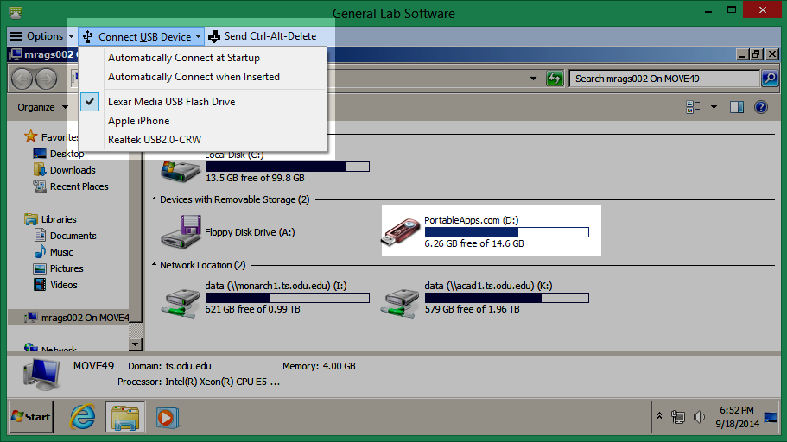

Simply pick out the name of the USB stick and, after a few moments, it will show up as a regular drive. The names of your USB stick will be different! In my case here: there is the USB stick, my iPhone, and my external fan. Simply File 🡪 Save to this location like you normally would.

The other way is to simply email the document to yourself by opening up a web browser inside of MoVE, heading to <http://my.odu.edu/>, logging in with your MIDAS, and emailing the document to yourself. Useful if you forgot your USB stick.

## Launching Dev-C++

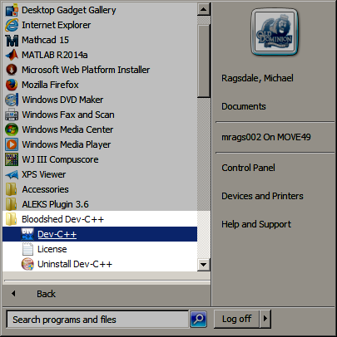

The older version of Dev-C++ that Dr. Kalburgi uses is installed right here on MoVE. Start 🡪 All Programs 🡪 Bloodshed Dev-C++ 🡪 Dev-C++ just like in class

# Dev-C++ on your own computer

## For older versions of Windows (XP, Vista, or 7)

The older version of Dev-C++, which is the version used in the classroom, can be downloaded here: <http://www.bloodshed.net/dev/devcpp.html>

THIS VERSION OF DEV-C++ WILL NOT RUN ON WINDOWS 8 OR WINDOWS 8.1!!!

## For modern versions of Windows (8, 8.1)

You will need to install the modern version of Dev-C++ which you can find here: <http://sourceforge.net/projects/orwelldevcpp/>

DO NOT COME CRYING TO DR. KALBURGI IF YOU MESS UP WHILE USING THE NEWER VERSION OF DEV-C++. WHEN IN DOUBT, USE MOVE INSTEAD.

## For Mac users

There are three ways you can use Dev-C++ on your Mac

* MoVE
* Bootcamp (included with OS X)
* Virtual Box

### Using MoVE (Easiest)

The easiest way is by using MoVE, as described above. This is probably the best way if you want to get started quickly.

For the adventurist who want to not mess with ODU’s MoVE, then please read on

### Installing Dev-C++ using Bootcamp

Bootcamp is a utility that comes on your Mac that allows you to install Windows onto your Mac, which would allow you to run Dev-C++ on your system. THIS IS FAIRLY ADVANCED AND IS ONLY FOR THOSE WHO FEEL CONFIDENT IN THEMSELVES AND THEIR ABILITIES!!

* First, you will need to download Windows and burn it to a DVD
  + Search your ODU email for “An Account has been created for you”
  + This is your Microsoft DreamSpark Premium information
  + Register for DreamSpark, and you will be able to download select Microsoft software (pretty much anything BUT Office)
  + Select the version of Windows that is compatible with your Mac (Vista, 7, 8, or 8.1) – DO NOT SELECT WINDOWS SERVER!!
    - Always select the latest version of Windows that can run on your version of Mac, see the instructions that came with Bootcamp for more
    - ALWAYS select Windows 8.1 if your Mac says it can handle Windows 8
    - Windows XP is NOT available on DreamSpark, since support has ended on April 2014. Follow the instructions for using MoVE
  + Download and burn this copy of Windows to a blank DVD (if you don’t know how, or don’t have a blank DVD, may I suggest you use MoVE)
* Bootcamp will walk you through getting your Mac set up using Windows
* Once Windows is installed, you will need to install the Mac Drivers
  + These are included on your OS X installation DVD
  + Refer to documentation that came with Bootcamp for information on how to install the drivers
* Install Dev-C++ using the instructions above for Windows users

### Using Virtual Box

Virtual Box allows you to install an operating system inside of another operating system. It is fairly complex, and if you are faint of heart, then may I suggest you use MoVE.

Simply follow the instructions above to download Windows – and select Windows 8.1 when given the choice. You do NOT need to burn it to a DVD. Download Virtual Box from [www.virtualbox.org](http://www.virtualbox.org) and create a new Guest. At minimum, I recommend you set the RAM size to 2048 MB and the hard drive size to 50 GB (100 GB is better). If your Mac has less than 4 GB of RAM, then you cannot use Virtual Box. Virtual Box has extensive documentation.

Once Windows is installed in Virtual Box, you will need to install the Guest Additions. Create a Shared Folder that Auto-Mounts and is Permanent. While inside of Virtual Box, you can save your files to that folder. Outside of Virtual Box, using your Finder, you can copy & paste these files between the Shared Folder and your USB drive

## For Linux users

Dev-C++ is rated Platinum when Wine is installed on your system <https://appdb.winehq.org/objectManager.php?sClass=application&iId=1178>

With Wine installed on your system, download and use Dev-C++ as you normally would. In addition, you are still free to use MoVE.

# Microsoft Visio (Homework Flowcharts)

Visio is a tool that is used to create diagrams, and we will be using it in class to create Flowcharts for Homework. Visio is installed on ODU computers, can be reached using MoVE, or you can download a copy onto your computer

* C1041 (the lab next to our classroom) has Visio
* Computers in Perry Library have Visio
* Our classroom has Visio

You can install Visio on your Windows computer (sorry Mac & Linux users). Simply search your ODU email for “an account has been created for you”. This is your Microsoft DreamSpark Premium account, from where you can download Visio onto your own system.

If you aren’t sure what you’re doing, please feel free to use MoVE or use a lab or library computer.